For Immediate Release | Contact: Janis Backing, 312-329-2108  janis.backing@moody.edu

What it Looks Like to Live in the Power of God
Debut Bible Study for Women: An Unexplainable Life by Erica Wiggenhorn

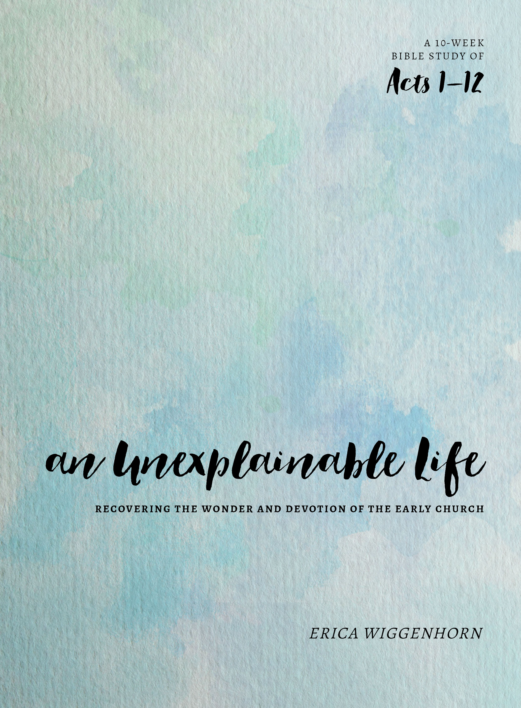
Chicago, IL – Do you ever feel like you’re living a “small” life? Do you look around and wonder if this is all there is? The truth is, Christ’s mission is much bigger than ourselves and many of us are missing out on the full life He offers. What would our lives look like if we lived in the power of God, fueled by the Holy Spirit? How can we live in a way that the world is left scratching their heads?

“Cultural influences, circumstances, and our own misconceptions have stifled the life of God in us, resulting in imprecise views of Christ’s mission for our lives both individually and in the Christian church collectively,” says Erica Wiggenhorn, author of the new Bible study, An Unexplainable Life (Moody Publishers, July 2016). “We have become men and women of doubt and fear. We are consumed by our circumstances.”

In this debut title in Moody Publishers’ new Bible study line for women, Wiggenhorn, a Bible teacher, speaker, and founder of EveryLife Ministries in Phoenix, takes women on a 50-day journey through Acts 1-12, helping them to understand biblical truths about the Holy Spirit, Pentecost, the early church, and the mission of the disciples.

Designed for small groups, churches, as well as individual study, An Unexplainable Life includes ten weeks of lessons, five per week, and features a daily Scripture passage (which women are encouraged to read aloud), commentary from Wiggenhorn, and in-depth, interactive questions. While many Bible studies on the book of Acts exist, Wiggenhorn’s hope is that this study will reignite a movement of the power of the Holy Spirit in each woman individually and in their churches collectively.

“The Holy Spirit was sent to authenticate Christ’s claims of deity,” says Wiggenhorn. “The Spirit powerfully manifests Himself in order for Christ’s prayers that the church will demonstrate an unexplainable love for Him and for one another are fulfilled. Yet we can lose our dependence on the Holy Spirit and attempt to manufacture our own power. But the Holy Spirit is our Counselor who guides us into all truth. He is the One who enables us to understand the Scriptures. He is the One who empowers us to live out the mission. He is able to work in and through us so the world may know the power of Christ.”

Throughout the study, Wiggenhorn guides women as they learn about unexplainable change, courage, mission, vision, expansion, unity, and discipleship as well as God and the journey we take toward an unexplainable life. She encourages women to pray boldly, build their knowledge of Scripture, serve, tell the truth, share their faith, and resolve to obey God’s leading, no matter what.

“Prayer is where we talk it through. The Word is where our spiritual warnings are given,” says Wiggenhorn. “Keeping in step with the Spirit requires diligence and perseverance, but when you have it down, your life becomes a beautiful display accompanied by a skillful melody—it becomes unexplainably harmonious!”

An Unexplainable Life: Recovering the Wonder and Devotion of the Early Church
by Erica Wiggenhorn
Moody Publishers, July 2016, ISBN: 978-0802414731

About the Author

Erica Wiggenhorn is the founder of Every Life Ministries, bringing you the truths of Scripture to transform your life. By digging deeply into God’s Word, Every Life Ministries encourages you to discover your unique purpose, accept God’s promises, and live by His power. Erica’s latest study An Unexplainable Life: Recovering the Wonder and Devotion of the Early Church is based on the first twelve chapters of Acts and released in July from Moody Publishers.

Erica serves on the women’s ministry leadership team for her church and regularly teaches in various venues. She’s also taught women in the Arizona State Prison system, and overseas. She loves to bring God’s Word to anyone who’ll listen!

A graduate and post-graduate of Azusa Pacific University, Erica lives in Phoenix with her husband, Jonathan, and their two children, Eliana and Nathan.

For more information, along with free resources that coincide with the study, visit ericawiggenhorn.com.

Suggested Discussion Questions

- What are some of the biggest lessons we can draw from the book of Acts?
- What does a life look like that’s lived in the power of God?
- Why do you think so many Christians struggle to live the life that God has promised to us?
- How does your study differ from other Bible studies on the book of Acts?
- How do you think women can especially identify with Peter and the changes he experiences in Acts?
- How have Christians distorted the truth about the Holy Spirit?
- Why is prayer such an important part of the life of the believer?

